

**Name: Manveer Singh A/L Daljit Singh**

**Student ID:**

**Subject: FIT1244 Internet Technology (November 22)**

**Lecturer: Mr. Shyam**

**Submission Date: 21/2/2023**  
  
Table of Contents

|  |  |
| --- | --- |
| Title | Page Number |
| Introduction | 3 |
| Plan | 4 |
| Page Contents and HTML, JavaScript Code | 5-49 |
| CSS Code | 49-57 |
| Conclusion | 58 |
| Reference | 59 |

# Introduction

For this assignment we will be creating a pest control company website. The name of the website is **Manzill Pest Control**. The purpose of designing this website is to let our customers to be more convenient to contact us and arrange an appointment to make their homes pest-free. This website is showing types of services in detail. For example, each service are being told to users on how it is implemented. Furthermore, this website is also used by employee to see their income and upcoming work. This website contains 16 pages including “**About**” and “**Contact**”.

Moreover, this website has also included customers review page. This is to gain the trust of the users about our services by seeing previous customers review.

In order to complete this task, we have used HTML, CSS and JavaScript. Necessary files for this website are saved as:

|  |  |  |
| --- | --- | --- |
| **File Name**  **(HTML)** | **External File Name (CSS)** | **External File Name (JS)** |
| testindex.html | ManzillStyleTest.css | - |
| servicepage.html | - |
| about.html | - |
| custreview.html | - |
| contact.html | - |
| login.html | admin.js |
| baiting.html | - |
| common flies.html | - |
| disinfection.html | - |
| general.html | - |
| post-construction.html | - |
| pre-construction.html | - |
| residual.html | - |
| rodent.html | - |
| streatment.html | - |
| thermalfogging.html | - |

# Plan

|  |  |  |
| --- | --- | --- |
| Task | Date | |
|  | **Starting Date** | **Ending Date** |
| Project plan | 10/01/2023 | 14/01/2023 |
| Design | 15/01/2023 | 18/01/2023 |
| Information collection | 19/01/2023 | 22/01/2023 |
| Diagrams | 23/01/2023 | 25/01/2023 |
| Html code | 26/01/2023 | 9/02/2023 |
| CSS code | 10/02/2023 | 16/02/2023 |
| Java Script | 17/09/2023 | 19/02/2023 |

# Description

## Home page

In the home page there are three main functions:

* Picture of shop and van
* About brief
* Service page brief
* Customer review brief

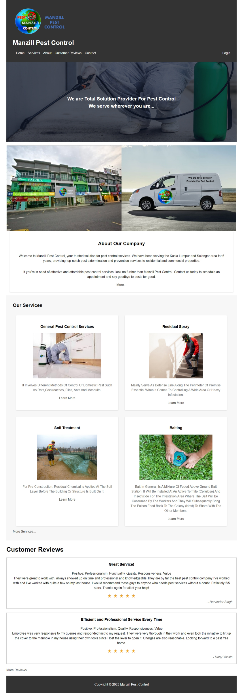



Figure 1 Home (index)

## Code for home page(index.html)

|  |
| --- |
| <!DOCTYPE html>  <html>  <head>  <title> Home | Manzill Pest Control</title>  <link href="fav.jpg" rel="icon" />  <link rel="stylesheet" href="ManzillStyleTest.css">  <script src="trans.js"></script>  </head>  <body>  <!-- Header -->  <header>  <img src="try.png" alt="Company Logo">  <h1>Manzill Pest Control</h1>  <nav>  <ul>  <li><a href="testindex.html">Home</a></li>  <li><a href="servicepage.html">Services</a></li>  <li><a href="about.html">About</a></li>  <li><a href="custreview.html">Customer Reviews</a></li>  <li><a href="contact.html">Contact</a></li>  </ul>  <a href="login.html">Login</a>  </nav>  </header>  <!-- Hero Section -->  <section class="hero">  <h2>We are Total Solution Provider For Pest Control <br> We serve wherever you are... </h2>  </section>  <!-- Picture Section -->  <section class="pictures">  <p></p>  <img src="shoppic.jpg" alt="Shop Picture">  <img src="van.jpg" alt="Van Picture">  </section>  <!-- About Section -->  <section class="about">  <h2> About Our Company </h2>  <p>Welcome to Manzill Pest Control, your trusted solution for pest control services. We have been serving the Kuala Lumpur and Selangor area for 6 years, providing top-notch pest extermination and prevention services to residential and commercial properties.</p>  <p>If you’re in need of effective and affordable pest control services, look no further than Manzill Pest Control. Contact us today to schedule an appointment and say goodbye to pests for good.</p>  <a href="about.html" class="button">More...</a>  </section>  <!-- Services Section -->  <section class="services">  <h2>Our Services</h2>  <ul>  <li>  <h3>General Pest Control Services</h3>  <img src="general pest.jpg" alt="General Pest Control">  <p>It Involves Different Methods Of Control Of Domestic Pest Such As Rats,Cockroaches, Flies, Ants And Mosquito.</p>  <a href="general.html" class="button">Learn More</a>  </li>  <li>  <h3>Residual Spray</h3>  <img src="residual spray.jpg" alt="Residual Spray">  <p>Mainly Serve As Defense Line Along The Perimeter Of Premise Essential When It Comes To Controlling A Wide Area Or Heavy Infestation.</p>  <a href="residual.html" class="button">Learn More</a>  </li>  <li>  <h3>Soil Treatment</h3>  <img src="soil treatment.jpg" alt="Soil Treatment">  <p> For Pre-Construction: Residual Chemical Is Applied At The Soil Layer Before The Building Or Structure Is Built On It.</p>  <a href="streatment.html" class="button">Learn More</a>  </li>  <li>  <h3>Baiting</h3>  <img src="baiting.jpg" alt="Baiting">  <p> Bait In General, Is A Mixture Of Fodod Above Ground Bait Station, It Will Be Installed At An Active Termite (Cellulose) And Insecticide For The Infestation Area Where The Bait Will Be Consumed By The Workers And They Will Subsequently Bring The Poison Food Back To The Colony (Nest) To Share With The Other Members.</p>  <a href="baiting.html" class="button">Learn More</a>  </li>  </ul>  <a href="servicepage.html" class="button">More Services...</a>  </section>  <!-- Customer Review Section -->  <div class="rev">  <h1>Customer Reviews</h1>  <div class="review">  <h3>Great Service!</h3>  <p>Positive: Professionalism, Punctuality, Quality, Responsiveness, Value <br>  They were great to work with, always showed up on time and professional and knowledgeable.They are by far the best pest control company I’ve worked with and I’ve worked with quite a few on my last house. I would recommend these guys to anyone who needs pest services without a doubt. Definitely 5/5 stars. Thanks again for all of your help!</p>  <div class="rating">  <span>★</span><span>★</span><span>★</span><span>★</span><span>★</span>  </div>  <div class="author">- Narvinder Singh</div>  </div>  <div class="review">  <h3>Efficient and Professional Service Every Time</h3>  <p>Positive: Professionalism, Quality, Responsiveness, Value <br>  Employee was very responsive to my queries and responded fast to my request. They were very thorough in their work and even took the initiative to lift up the cover to the manhole in my house using their own tools since I lost the lever to open it. Charges are also reasonable. Looking forward to a pest free home.</p>  <div class="rating">  <span>★</span><span>★</span><span>★</span><span>★</span><span>★</span>  </div>  <div class="author">- Hany Yassin</div>  </div>  <a href="custreview.html" class="button">More Reviews...</a>  <p></p>  </div>  <!-- Footer -->  <footer>  <p>Copyright &copy; 2023 Manzill Pest Control</p>  </footer>  </body>  </html> |

# Services

In this section, there are three functions:

* All range of service provided
* Book appointment through WhatsApp button
* 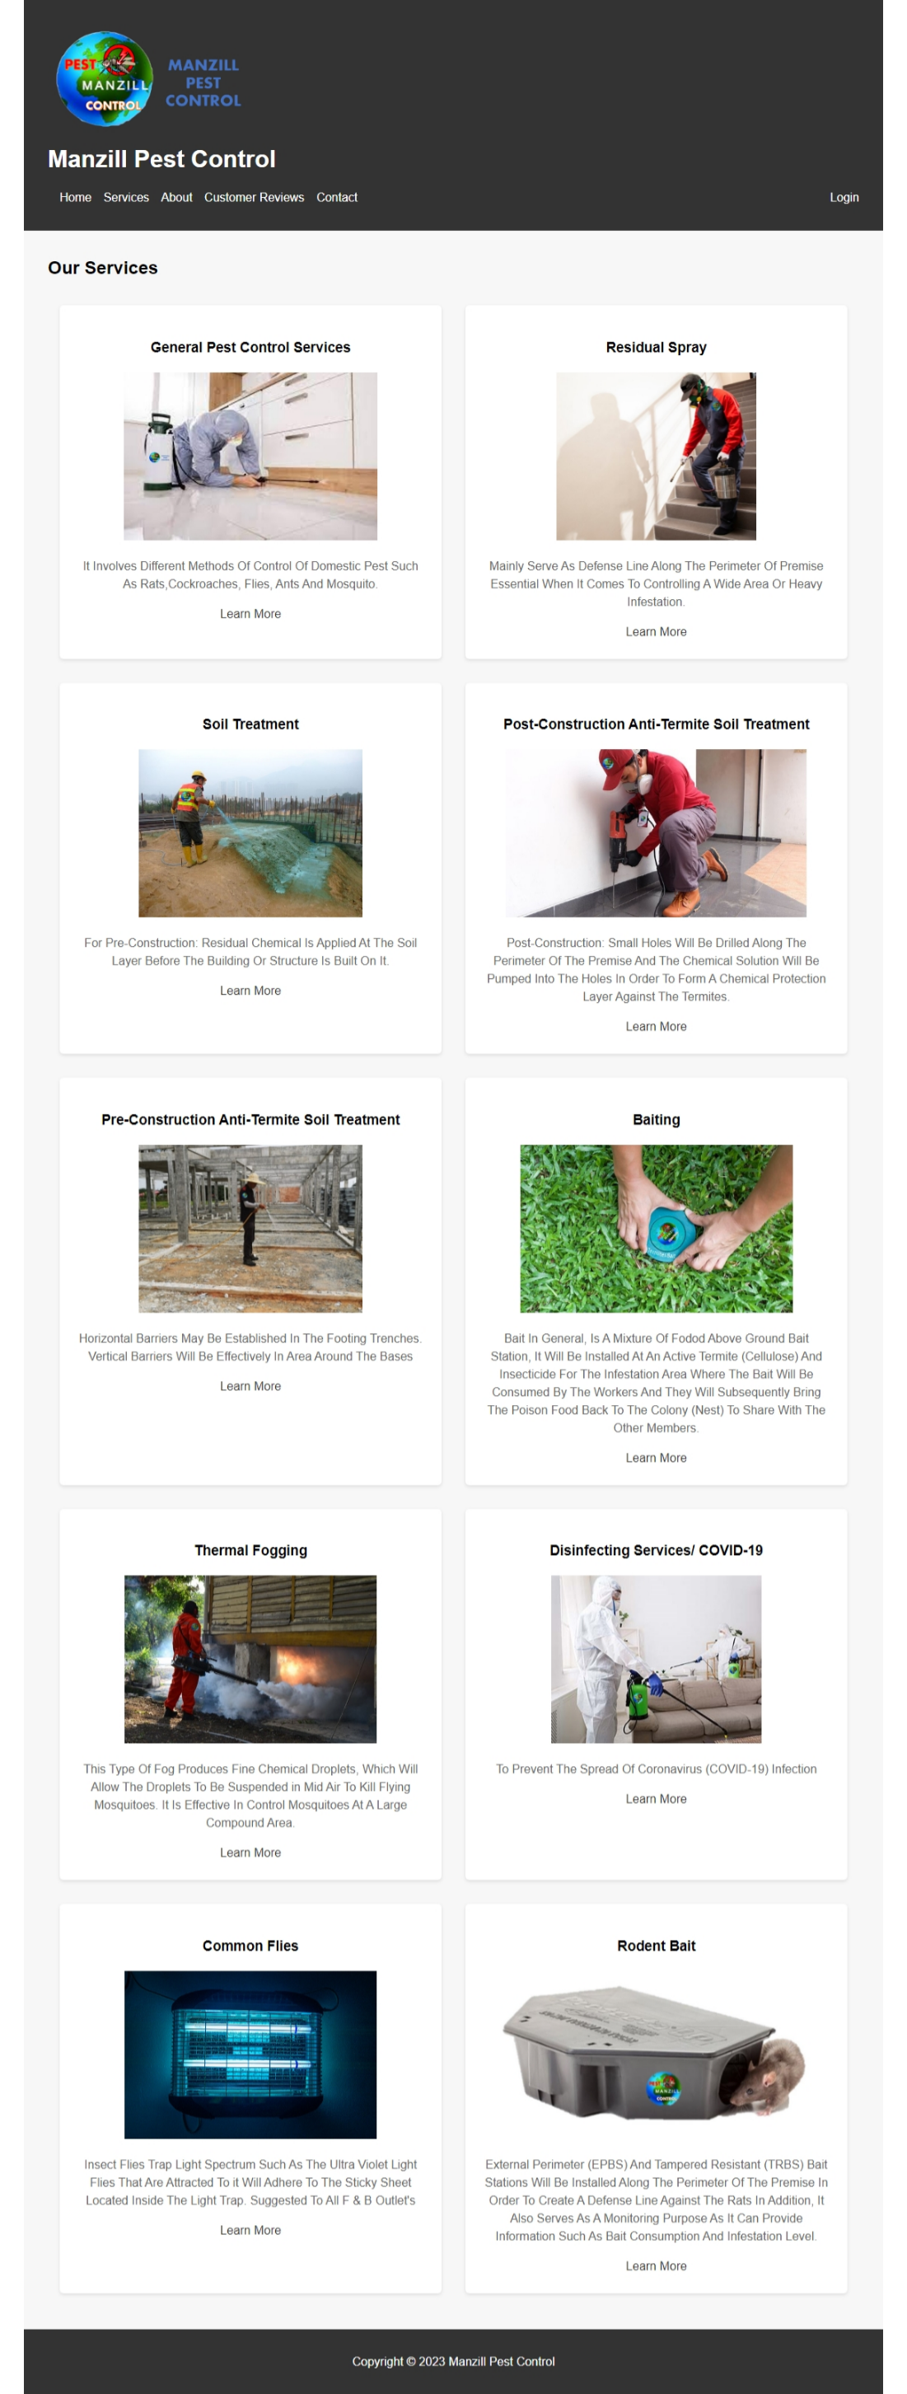Call button



Figure 2 Services

## Code for Services (servicepage.html)

|  |
| --- |
| <!DOCTYPE html>  <html>  <head>  <title> Services | Manzill Pest Control</title>  <link href="fav.jpg" rel="icon" />  <link rel="stylesheet" href="ManzillStyleTest.css">  </head>  <body>  <!-- Header -->  <header>  <img src="try.png" alt="Company Logo">  <h1>Manzill Pest Control</h1>  <nav>  <ul>  <li><a href="testindex.html">Home</a></li>  <li><a href="servicepage.html">Services</a></li>  <li><a href="about.html">About</a></li>  <li><a href="custreview.html">Customer Reviews</a></li>  <li><a href="contact.html">Contact</a></li>  </ul>  <a href="login.html">Login</a>  </nav>  </header>  <!-- Services Section -->  <section class="services">  <h2>Our Services</h2>  <ul>  <li>  <h3>General Pest Control Services</h3>  <img src="general pest.jpg" alt="General Pest Control">  <p>It Involves Different Methods Of Control Of Domestic Pest Such As Rats,Cockroaches, Flies, Ants And Mosquito.</p>  <a href="general.html" class="button">Learn More</a>  </li>  <li>  <h3>Residual Spray</h3>  <img src="residual spray.jpg" alt="Residual Spray">  <p>Mainly Serve As Defense Line Along The Perimeter Of Premise Essential When It Comes To Controlling A Wide Area Or Heavy Infestation.</p>  <a href="residual.html" class="button">Learn More</a>  </li>  <li>  <h3>Soil Treatment</h3>  <img src="soil treatment.jpg" alt="Soil Treatment">  <p> For Pre-Construction: Residual Chemical Is Applied At The Soil Layer Before The Building Or Structure Is Built On It.</p>  <a href="streatment.html" class="button">Learn More</a>  </li>  <li>  <h3>Post-Construction Anti-Termite Soil Treatment</h3>  <img src="post-construction.jpg" alt="Post-Construction Anti-Termite Soil Treatment">  <p> Post-Construction: Small Holes Will Be Drilled Along The Perimeter Of The Premise And The Chemical Solution Will Be Pumped Into The Holes In Order To Form A Chemical Protection Layer Against The Termites. </p>  <a href="post-construction.html" class="button">Learn More</a>  </li>  <li>  <h3>Pre-Construction Anti-Termite Soil Treatment</h3>  <img src="pre-construction.jpg" alt="Pre-Construction Anti-Termite Soil Treatment">  <p> Horizontal Barriers May Be Established In The Footing Trenches. Vertical Barriers Will Be Effectively In Area Around The Bases</p>  <a href="pre-construction.html" class="button">Learn More</a>  </li>  <li>  <h3>Baiting</h3>  <img src="baiting.jpg" alt="Baiting">  <p> Bait In General, Is A Mixture Of Fodod Above Ground Bait Station, It Will Be Installed At An Active Termite (Cellulose) And Insecticide For The Infestation Area Where The Bait Will Be Consumed By The Workers And They Will Subsequently Bring The Poison Food Back To The Colony (Nest) To Share With The Other Members.</p>  <a href="baiting.html" class="button">Learn More</a>  </li>  <li>  <h3>Thermal Fogging</h3>  <img src="thermal fogging.jpg" alt="Thermal Fogging">  <p> This Type Of Fog Produces Fine Chemical Droplets, Which Will Allow The Droplets To Be Suspended in Mid Air To Kill Flying Mosquitoes. It Is Effective In Control Mosquitoes At A Large Compound Area.</p>  <a href="thermalfogging.html" class="button">Learn More</a>  </li>  <li>  <h3>Disinfecting Services/ COVID-19 </h3>  <img src="disinfection.jpg" alt="Disinfecting Services">  <p>To Prevent The Spread Of Coronavirus (COVID-19) Infection</p>  <a href="disinfection.html" class="button">Learn More</a>  </li>  <li>  <h3>Common Flies</h3>  <img src="common flies.jpg" alt="Common Flies">  <p> Insect Flies Trap Light Spectrum Such As The Ultra Violet Light Flies That Are Attracted To it Will Adhere To The Sticky Sheet Located Inside The Light Trap. Suggested To All F & B Outlet's</p>  <a href="common flies.html" class="button">Learn More</a>  </li>  <li>  <h3>Rodent Bait</h3>  <img src="rodent.jpg" alt="Rodent Bait">  <p> External Perimeter (EPBS) And Tampered Resistant (TRBS) Bait Stations Will Be Installed Along The Perimeter Of The Premise In Order To Create A Defense Line Against The Rats In Addition, It Also Serves As A Monitoring Purpose As It Can Provide Information Such As Bait Consumption And Infestation Level.</p>  <a href="rodent.html" class="button">Learn More</a>  </li>  </ul>  </section>  <!-- Footer -->  <footer>  <p>Copyright &copy; 2023 Manzill Pest Control</p>  </footer>  </body>  </html> |

# About

In this section, people can read about our company history and partners.

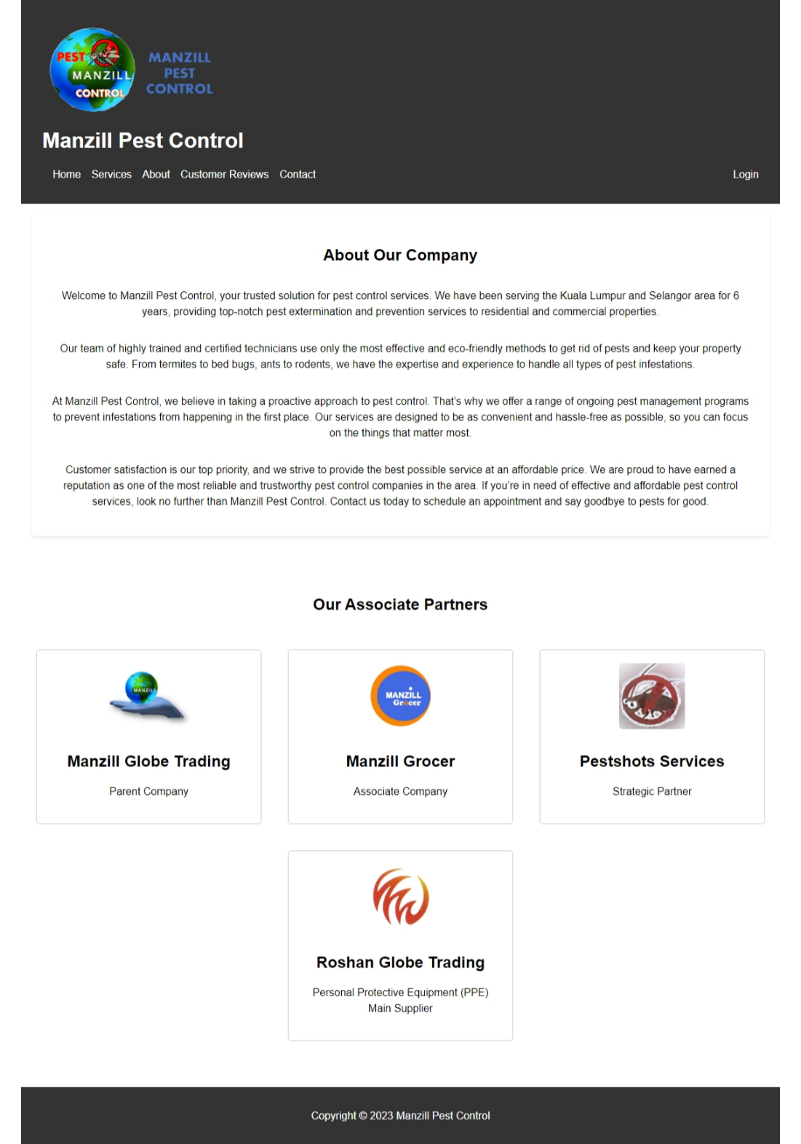

Figure 3 About

Code for About (about.html)

|  |
| --- |
| <!DOCTYPE html>  <html>  <head>  <title> About | Manzill Pest Control</title>  <link href="fav.jpg" rel="icon" />  <link rel="stylesheet" href="ManzillStyleTest.css">  </head>  <body>  <!-- Header -->  <header>  <img src="try.png" alt="Company Logo">  <h1>Manzill Pest Control</h1>  <nav>  <ul>  <li><a href="testindex.html">Home</a></li>  <li><a href="servicepage.html">Services</a></li>  <li><a href="about.html">About</a></li>  <li><a href="custreview.html">Customer Reviews</a></li>  <li><a href="contact.html">Contact</a></li>  </ul>  <a href="login.html">Login</a>  </nav>  </header>  <!-- About Section -->  <section class="about">  <h2> About Our Company </h2>  <p>Welcome to Manzill Pest Control, your trusted solution for pest control services. We have been serving the Kuala Lumpur and Selangor area for 6 years, providing top-notch pest extermination and prevention services to residential and commercial properties.</p>  <p>Our team of highly trained and certified technicians use only the most effective and eco-friendly methods to get rid of pests and keep your property safe. From termites to bed bugs, ants to rodents, we have the expertise and experience to handle all types of pest infestations.</p>  <p>At Manzill Pest Control, we believe in taking a proactive approach to pest control. That’s why we offer a range of ongoing pest management programs to prevent infestations from happening in the first place. Our services are designed to be as convenient and hassle-free as possible, so you can focus on the things that matter most.</p>  <p>Customer satisfaction is our top priority, and we strive to provide the best possible service at an affordable price. We are proud to have earned a reputation as one of the most reliable and trustworthy pest control companies in the area. If you’re in need of effective and affordable pest control services, look no further than Manzill Pest Control. Contact us today to schedule an appointment and say goodbye to pests for good.</p>  </section>  <section class="partner-section">  <h2>Our Associate Partners</h2>  <div class="partner-list">  <div class="partner">  <a href="https://www.facebook.com/ManzillGlobe"><img src="GlobeTrading.jpg" alt="Manzill Globe Trading"></a>  <h3>Manzill Globe Trading</h3>  <p>Parent Company</p>  </div>  <div class="partner">  <a href="https://www.facebook.com/ManzillGrocer"><img src="Grocer.jpg" alt="Manzill Grocer"></a>  <h3>Manzill Grocer</h3>  <p>Associate Company</p>  </div>  <div class="partner">  <a href="https://www.facebook.com/Pestshotsservices"><img src="Pestshots.png" alt="Pestshots Services"></a>  <h3>Pestshots Services</h3>  <p>Strategic Partner</p>  </div>  <div class="partner">  <a href="https://www.facebook.com/roshanglobetrading"><img src="Roshan.png" alt="Roshan Globe Trading"></a>  <h3>Roshan Globe Trading</h3>  <p>Personal Protective Equipment (PPE) Main Supplier </p>  </div>  </div>  </section>    <!-- Footer -->  <footer>  <p>Copyright &copy; 2023 Manzill Pest Control</p>  </footer>  </body>  </html> |

# Customer Review

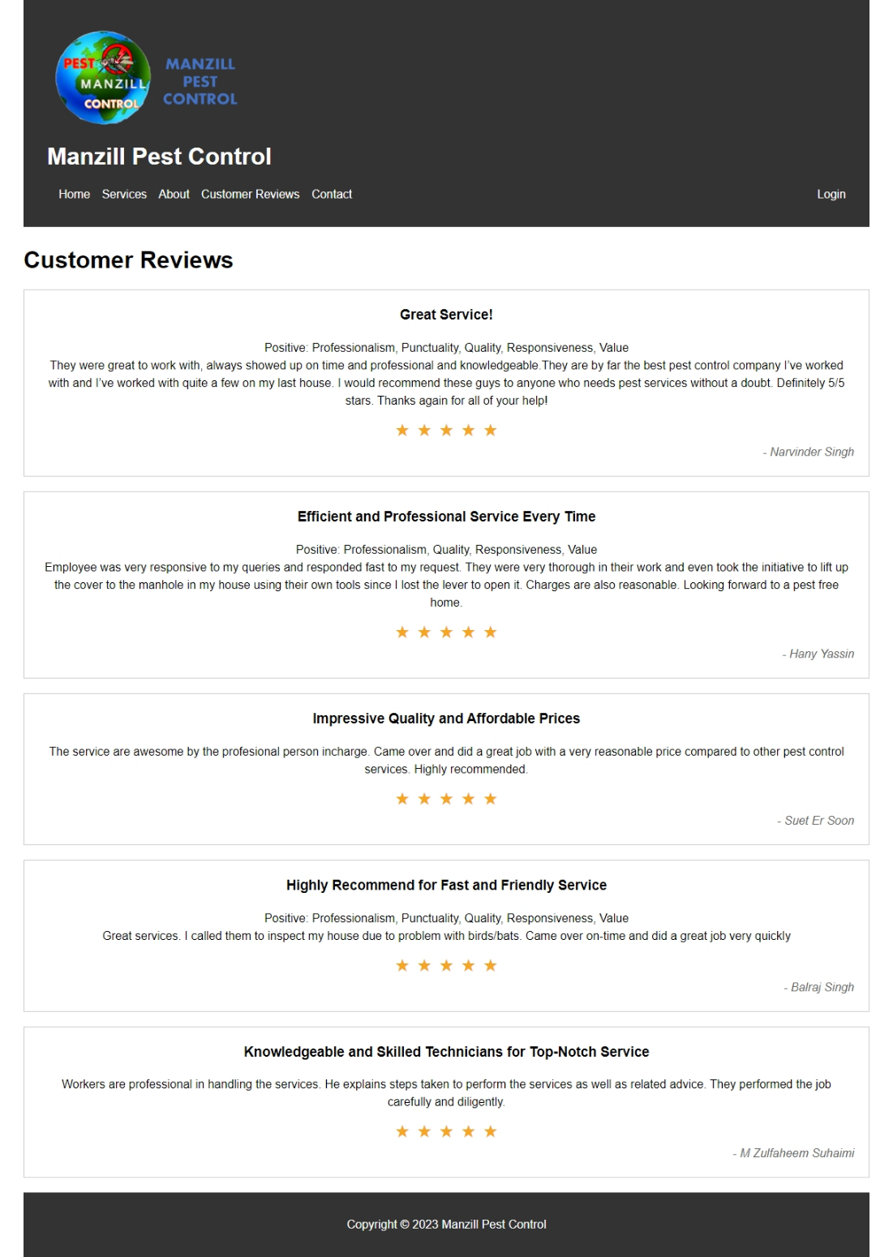Here customers can get familiar with our background and can see the details of what we do here.

Figure 4 Customer Review

**Code for Customer Review (custreview.html)**

|  |
| --- |
| <!DOCTYPE html>  <html>  <head>  <title> Customer Reviews | Manzill Pest Control</title>  <link href="fav.jpg" rel="icon" />  <script src="admin.js"></script>  <link rel="stylesheet" href="ManzillStyleTest.css">  </head>  <body>  <!-- Header -->  <header>  <img src="try.png" alt="Company Logo">  <h1>Manzill Pest Control</h1>  <nav>  <ul>  <li><a href="testindex.html">Home</a></li>  <li><a href="servicepage.html">Services</a></li>  <li><a href="about.html">About</a></li>  <li><a href="custreview.html">Customer Reviews</a></li>  <li><a href="contact.html">Contact</a></li>  </ul>  <a href="login.html">Login</a>  </nav>  </header>  <!-- Customer Review Section -->  <div class="rev">  <h1>Customer Reviews</h1>  <div class="review">  <h3>Great Service!</h3>  <p>Positive: Professionalism, Punctuality, Quality, Responsiveness, Value <br>  They were great to work with, always showed up on time and professional and knowledgeable.They are by far the best pest control company I’ve worked with and I’ve worked with quite a few on my last house. I would recommend these guys to anyone who needs pest services without a doubt. Definitely 5/5 stars. Thanks again for all of your help!</p>  <div class="rating">  <span>★</span><span>★</span><span>★</span><span>★</span><span>★</span>  </div>  <div class="author">- Narvinder Singh</div>  </div>  <div class="review">  <h3>Efficient and Professional Service Every Time</h3>  <p>Positive: Professionalism, Quality, Responsiveness, Value <br>  Employee was very responsive to my queries and responded fast to my request. They were very thorough in their work and even took the initiative to lift up the cover to the manhole in my house using their own tools since I lost the lever to open it. Charges are also reasonable. Looking forward to a pest free home.</p>  <div class="rating">  <span>★</span><span>★</span><span>★</span><span>★</span><span>★</span>  </div>  <div class="author">- Hany Yassin</div>  </div>  <div class="review">  <h3>Impressive Quality and Affordable Prices</h3>  <p>The service are awesome by the profesional person incharge. Came over and did a great job with a very reasonable price compared to other pest control services. Highly recommended.</p>  <div class="rating">  <span>★</span><span>★</span><span>★</span><span>★</span><span>★</span>  </div>  <div class="author">- Suet Er Soon</div>  </div>  <div class="review">  <h3>Highly Recommend for Fast and Friendly Service</h3>  <p>Positive: Professionalism, Punctuality, Quality, Responsiveness, Value <br>  Great services. I called them to inspect my house due to problem with birds/bats. Came over on-time and did a great job very quickly</p>  <div class="rating">  <span>★</span><span>★</span><span>★</span><span>★</span><span>★</span>  </div>  <div class="author">- Balraj Singh</div>  </div>  <div class="review">  <h3>Knowledgeable and Skilled Technicians for Top-Notch Service</h3>  <p>Workers are professional in handling the services. He explains steps taken to perform the services as well as related advice. They performed the job carefully and diligently.</p>  <div class="rating">  <span>★</span><span>★</span><span>★</span><span>★</span><span>★</span>  </div>  <div class="author">- M Zulfaheem Suhaimi</div>  </div>  </div>  </div>    <!-- Footer -->  <footer>  <p>Copyright &copy; 2023 Manzill Pest Control</p>  </footer>  </body>  </html> |

# Contact

If any customer wants to contact us for any question or feedback, they can directly contact us with the given information in this page.

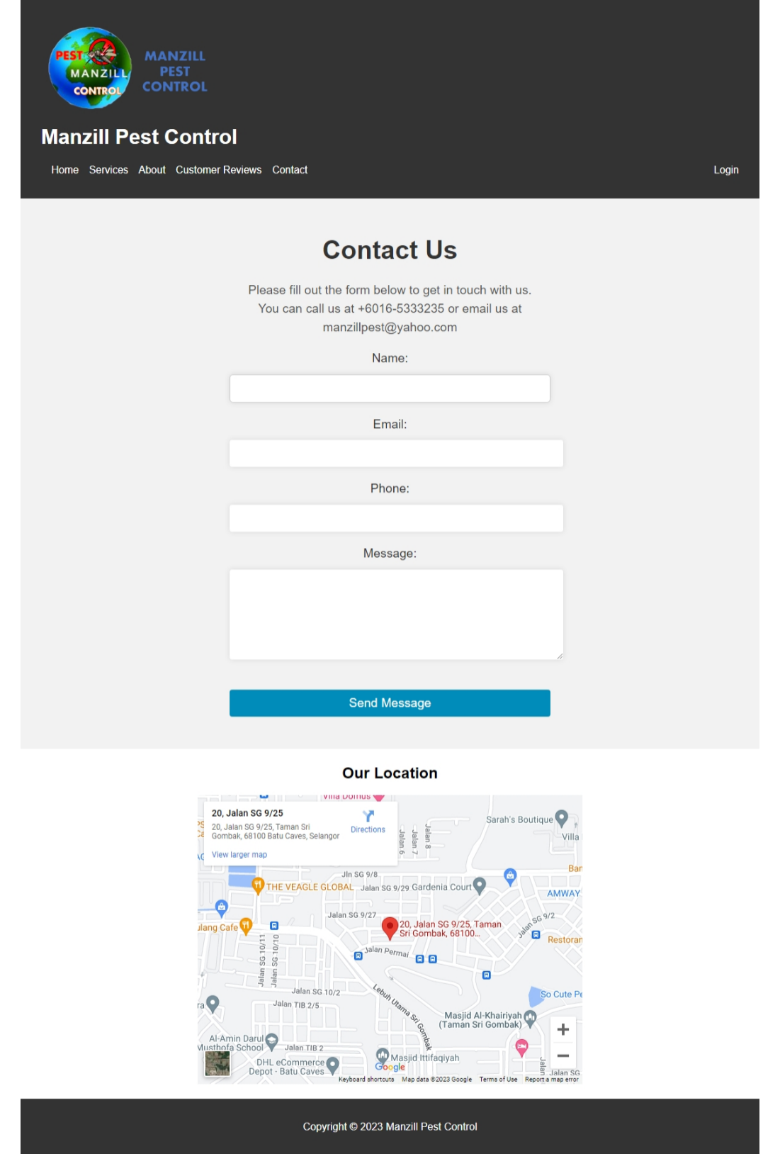

Figure 5 Contact

**Code for Contact (contact.html)**

|  |
| --- |
| <!DOCTYPE html>  <html>  <head>  <title> Contact | Manzill Pest Control</title>  <link href="fav.jpg" rel="icon" />  <link rel="stylesheet" href="ManzillStyleTest.css">  </head>  <body>  <!-- Header -->  <header>  <img src="try.png" alt="Company Logo">  <h1>Manzill Pest Control</h1>  <nav>  <ul>  <li><a href="testindex.html">Home</a></li>  <li><a href="servicepage.html">Services</a></li>  <li><a href="about.html">About</a></li>  <li><a href="custreview.html">Customer Reviews</a></li>  <li><a href="contact.html">Contact</a></li>  </ul>  <a href="login.html">Login</a>  </nav>  </header>  <!-- Details Section -->  <section id="contact">  <div class="contactus">  <h1>Contact Us</h1>  <p>Please fill out the form below to get in touch with us.<br> You can call us at +6016-5333235 or email us at manzillpest@yahoo.com</p>  <form action="submit-form.php" method="post">  <label for="name">Name:</label>  <input type="text" id="name" name="name" required>  <br>  <label for="email">Email:</label>  <input type="email" id="email" name="email" required>  <br>  <label for="phone">Phone:</label>  <input type="tel" id="phone" name="phone">  <br>  <label for="message">Message:</label>  <textarea id="message" name="message" required></textarea>  <br>  <button type="reset">Send Message</button>  </form>  </div>  </section>  <section id="maps">  <div class="map">  <h1>Our Location</h1>  <iframe src="https://www.google.com/maps/embed?pb=!1m18!1m12!1m3!1d3983.4017102596586!2d101.69601621510688!3d3.2499158534303714!2m3!1f0!2f0!3f0!3m2!1i1024!2i768!4f13.1!3m3!1m2!1s0x31cc4767801338c9%3A0xc5991d9a13085a2b!2s20%2C%20Jalan%20SG%209%2F25%2C%20Taman%20Sri%20Gombak%2C%2068100%20Batu%20Caves%2C%20Selangor!5e0!3m2!1sen!2smy!4v1677332659533!5m2!1sen!2smy" width="600" height="450" style="border:0;" allowfullscreen="" loading="lazy" referrerpolicy="no-referrer-when-downgrade"></iframe>  <p></p>  </div>  </section>        <!-- Footer -->  <footer>  <p>Copyright &copy; 2023 Manzill Pest Control</p>  </footer>  </body>  </html> |

# Employee Login

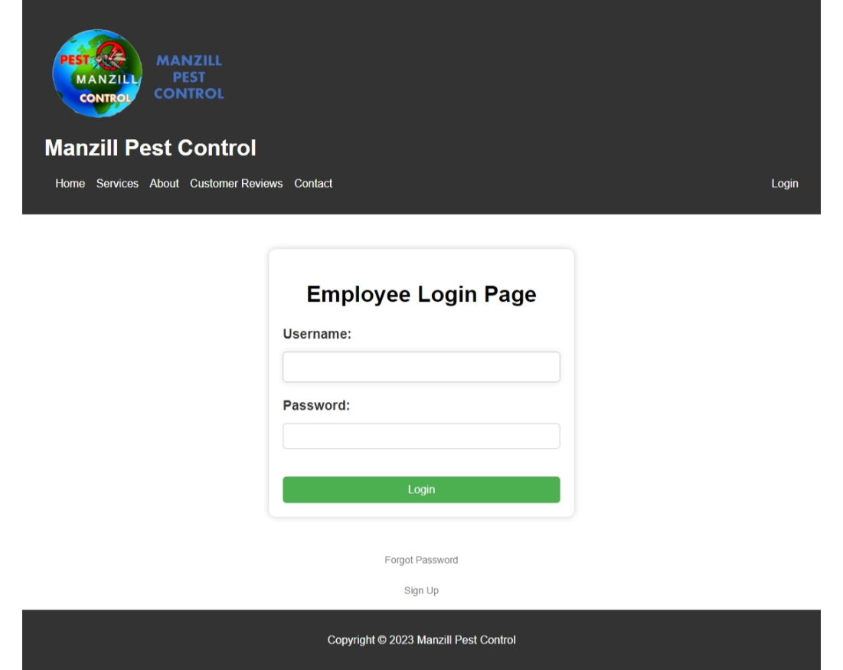Employee login to check their income and upcoming work to be done.

Figure 5 Contact

**Code for Login (login.html)**

|  |
| --- |
| <!DOCTYPE html>  <html>  <head>  <title> Employee Login | Manzill Pest Control</title>  <link href="fav.jpg" rel="icon" />  <script src="admin.js"></script>  <link rel="stylesheet" href="ManzillStyleTest.css">  </head>  <body>  <!-- Header -->  <header>  <img src="try.png" alt="Company Logo">  <h1>Manzill Pest Control</h1>  <nav>  <ul>  <li><a href="testindex.html">Home</a></li>  <li><a href="servicepage.html">Services</a></li>  <li><a href="about.html">About</a></li>  <li><a href="custreview.html">Customer Reviews</a></li>  <li><a href="contact.html">Contact</a></li>  </ul>  <a href="login.html">Login</a>  </nav>  </header>  <!-- Login Section -->  <div class="loginpg">  <h1>Employee Login Page</h1>  <form action="#" method="post">  <label for="username">Username:</label>  <input type="text" id="username" name="username" required>  <label for="password">Password:</label>  <input type="password" id="password" name="password" required>  <button type="submit" href="#">Login</button>  </form>  </div>  <div class="forgot-password">  <a onclick="forgotPassword()">Forgot Password</a>  </div>  <div class="signup">  <a onclick="signUp()">Sign Up</a>  </div>  <p></p>  <p></p>    <!-- Footer -->  <footer>  <p>Copyright &copy; 2023 Manzill Pest Control</p>  </footer>  </body>  </html> |

**Code for Login JavaScript (admin.js)**

|  |
| --- |
| function forgotPassword() {  alert("Please contact your administrator for password reset for your employer login account.");  }  function signUp() {  alert("Please contact your administrator for an employer login account.");  } |

# Services Page

In our website we have many different services such as Generral Pest Control, Baiting, Residual Spray etc.

## General Pest Control

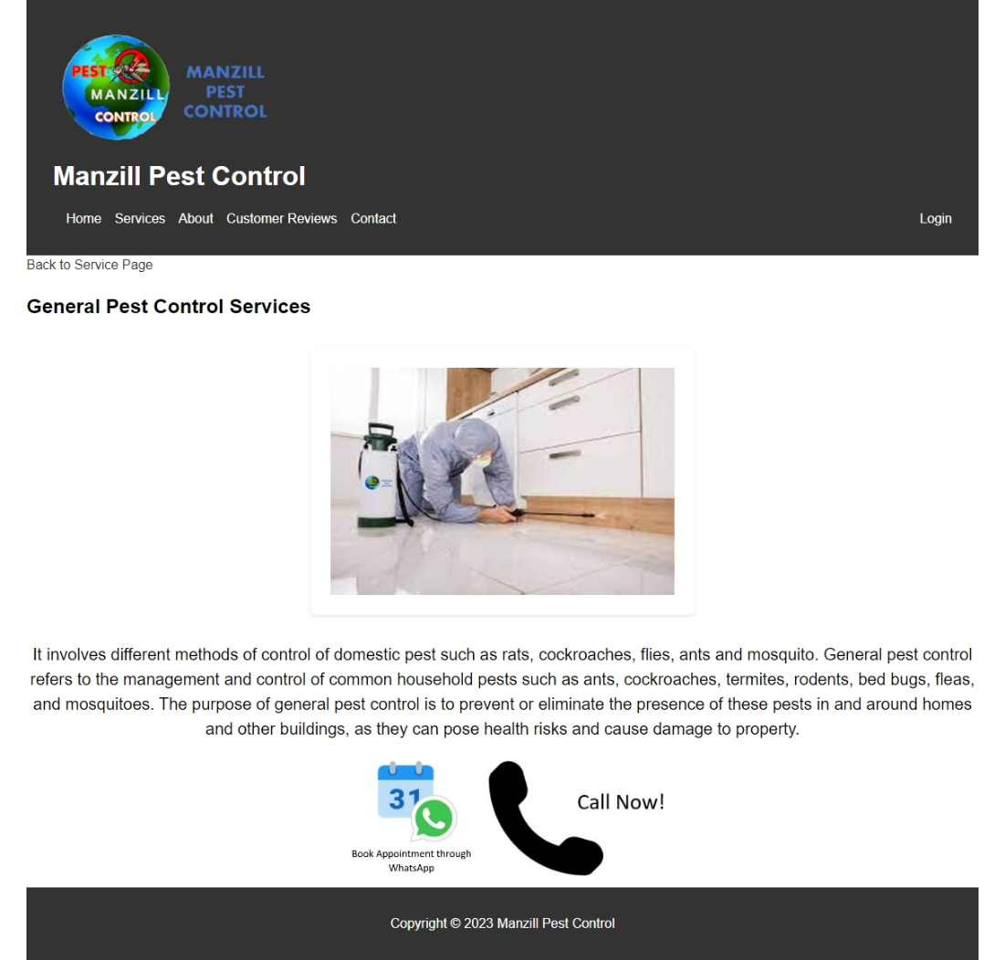

Figure 6 General Pest Control

**Code for General Pest Control (general.html)**

|  |
| --- |
| <!DOCTYPE html>  <html>  <head>  <title> Services | Manzill Pest Control</title>  <link href="fav.jpg" rel="icon" />  <link rel="stylesheet" href="ManzillStyleTest.css">  </head>  <body>  <!-- Header -->  <header>  <img src="try.png" alt="Company Logo">  <h1>Manzill Pest Control</h1>  <nav>  <ul>  <li><a href="testindex.html">Home</a></li>  <li><a href="servicepage.html">Services</a></li>  <li><a href="about.html">About</a></li>  <li><a href="custreview.html">Customer Reviews</a></li>  <li><a href="contact.html">Contact</a></li>  </ul>  <a href="login.html">Login</a>  </nav>  </header>  <!-- Service Section -->  <a href="servicepage.html" class="button">Back to Service Page</a>  <section class="servicesec">  <h2> General Pest Control Services </h2>  </section>  <div class="vicephoto">  <img src="general pest.jpg" alt="General Pest Control">  </div>  <div class="vicetext">  <p>It involves different methods of control of domestic pest such as rats, cockroaches, flies, ants and mosquito.  General pest control refers to the management and control of common household pests such as ants, cockroaches, termites, rodents, bed bugs, fleas, and mosquitoes. The purpose of general pest control is to prevent or eliminate the presence of these pests in and around homes and other buildings, as they can pose health risks and cause damage to property.</p>  </div>  <div class="appoint">  <a href="https://wa.me/+60165333235/"><img src="appointment.jpg" alt="Book Appointment through WhatsApp"></a>  <a href="tel:+60165333235"><img src="callnow.jpg" alt="Call Now!"></a>  </div>    <!-- Footer -->  <footer>  <p>Copyright &copy; 2023 Manzill Pest Control</p>  </footer>  </body>  </html> |

## Residual Spray

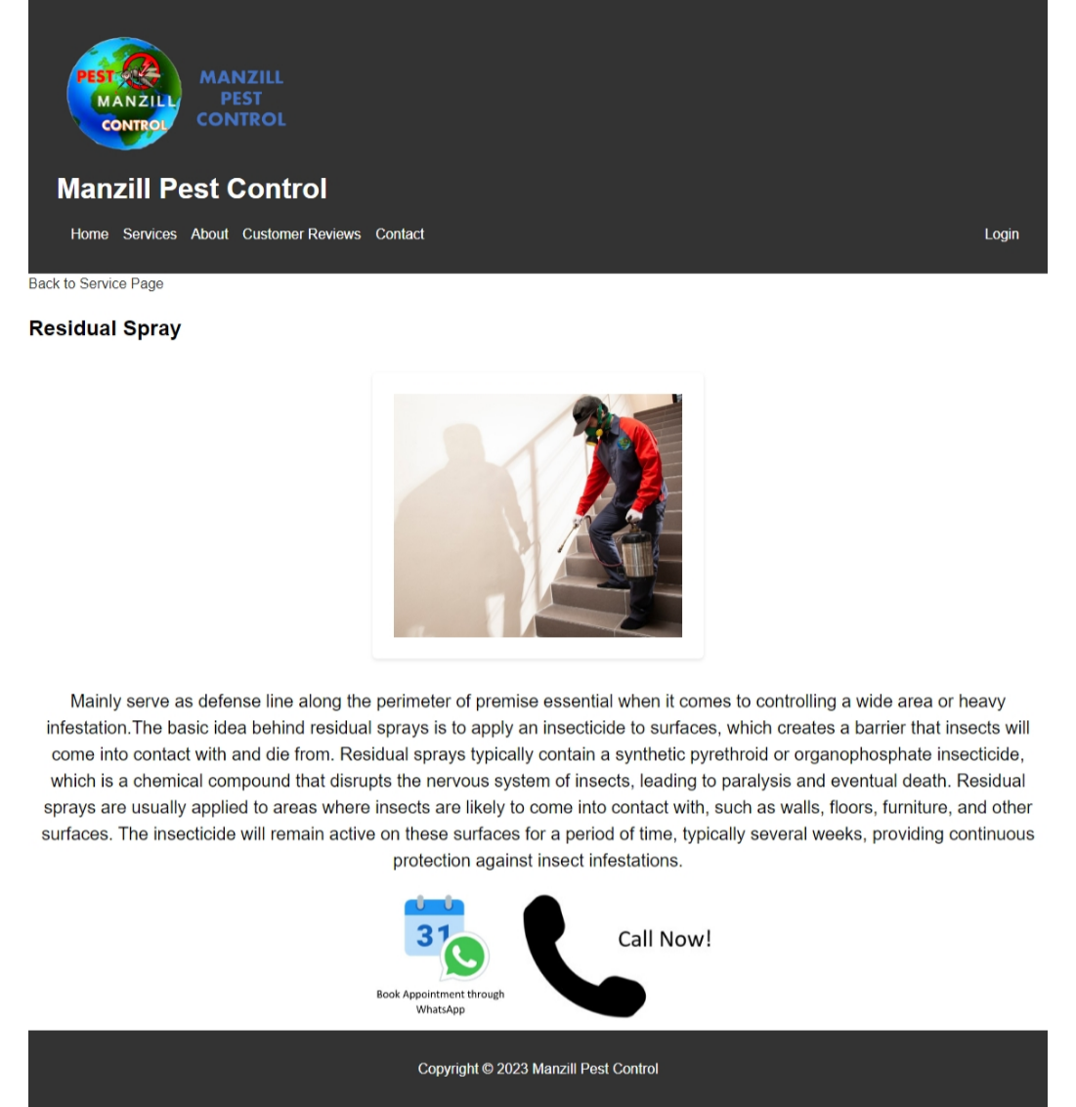

Figure 7 Residual Spray

**Code for Residual Spray (residual.html)**

|  |
| --- |
| <!DOCTYPE html>  <html>  <head>  <title> Services | Manzill Pest Control</title>  <link href="fav.jpg" rel="icon" />  <link rel="stylesheet" href="ManzillStyleTest.css">  </head>  <body>  <!-- Header -->  <header>  <img src="try.png" alt="Company Logo">  <h1>Manzill Pest Control</h1>  <nav>  <ul>  <li><a href="testindex.html">Home</a></li>  <li><a href="servicepage.html">Services</a></li>  <li><a href="about.html">About</a></li>  <li><a href="custreview.html">Customer Reviews</a></li>  <li><a href="contact.html">Contact</a></li>  </ul>  <a href="login.html">Login</a>  </nav>  </header>  <!-- Service Section -->  <a href="servicepage.html" class="button">Back to Service Page</a>  <section class="servicesec">  <h2> Residual Spray </h2>  </section>  <div class="vicephoto">  <img src="residual spray.jpg" alt="Residual Spray">  </div>  <div class="vicetext">  <p>Mainly serve as defense line along the perimeter of premise essential when it comes to controlling a wide area or heavy infestation.The basic idea behind residual sprays is to apply an insecticide to surfaces, which creates a barrier that insects will come into contact with and die from. Residual sprays typically contain a synthetic pyrethroid or organophosphate insecticide, which is a chemical compound that disrupts the nervous system of insects, leading to paralysis and eventual death. Residual sprays are usually applied to areas where insects are likely to come into contact with, such as walls, floors, furniture, and other surfaces. The insecticide will remain active on these surfaces for a period of time, typically several weeks, providing continuous protection against insect infestations.</p>  </div>  <div class="appoint">  <a href="https://wa.me/+60165333235/"><img src="appointment.jpg" alt="Book Appointment through WhatsApp"></a>  <a href="tel:+60165333235"><img src="callnow.jpg" alt="Call Now!"></a>  </div>    <!-- Footer -->  <footer>  <p>Copyright &copy; 2023 Manzill Pest Control</p>  </footer>  </body>  </html> |

## Soil Treatment

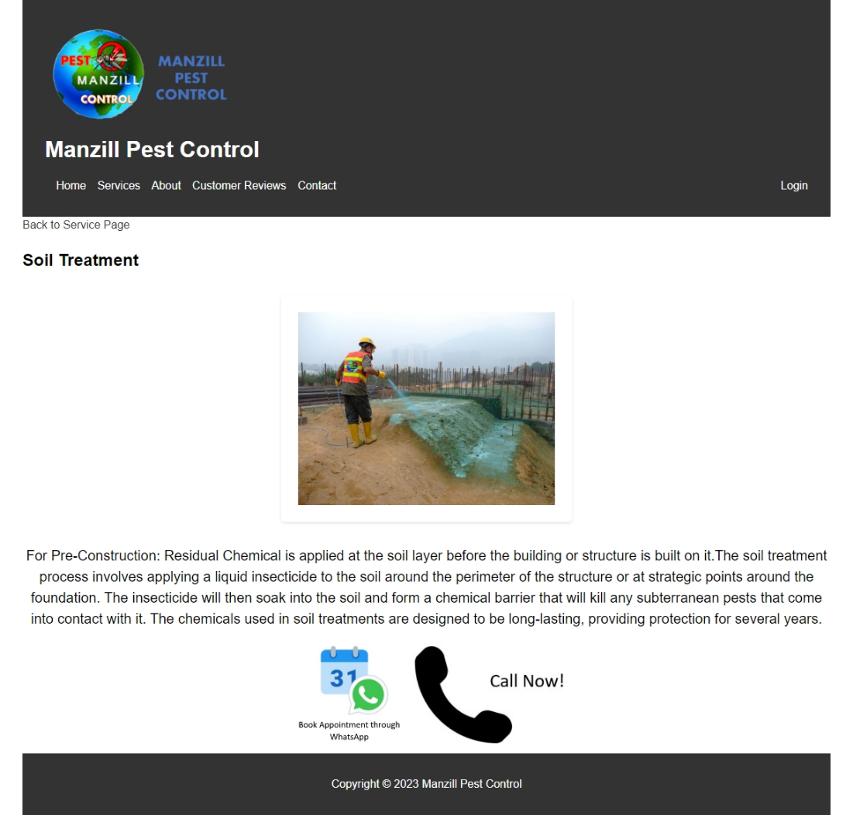

Figure 8 Soil Treatment

|  |
| --- |
| <!DOCTYPE html>  <html>  <head>  <title> Services | Manzill Pest Control</title>  <link href="fav.jpg" rel="icon" />  <link rel="stylesheet" href="ManzillStyleTest.css">  </head>  <body>  <!-- Header -->  <header>  <img src="try.png" alt="Company Logo">  <h1>Manzill Pest Control</h1>  <nav>  <ul>  <li><a href="testindex.html">Home</a></li>  <li><a href="servicepage.html">Services</a></li>  <li><a href="about.html">About</a></li>  <li><a href="custreview.html">Customer Reviews</a></li>  <li><a href="contact.html">Contact</a></li>  </ul>  <a href="login.html">Login</a>  </nav>  </header>  <!-- Service Section -->  <a href="servicepage.html" class="button">Back to Service Page</a>  <section class="servicesec">  <h2> Soil Treatment </h2>  </section>  <div class="vicephoto">  <img src="soil treatment.jpg" alt="Soil Treatment">  </div>  <div class="vicetext">  <p>For Pre-Construction: Residual Chemical is applied at the soil layer before the building or structure is built on it.The soil treatment process involves applying a liquid insecticide to the soil around the perimeter of the structure or at strategic points around the foundation. The insecticide will then soak into the soil and form a chemical barrier that will kill any subterranean pests that come into contact with it. The chemicals used in soil treatments are designed to be long-lasting, providing protection for several years.</p>  </div>  <div class="appoint">  <a href="https://wa.me/+60165333235/"><img src="appointment.jpg" alt="Book Appointment through WhatsApp"></a>  <a href="tel:+60165333235"><img src="callnow.jpg" alt="Call Now!"></a>  </div>    <!-- Footer -->  <footer>  <p>Copyright &copy; 2023 Manzill Pest Control</p>  </footer>  </body>  </html> |

**Post-Construction Anti-Termite Soil Treatment**

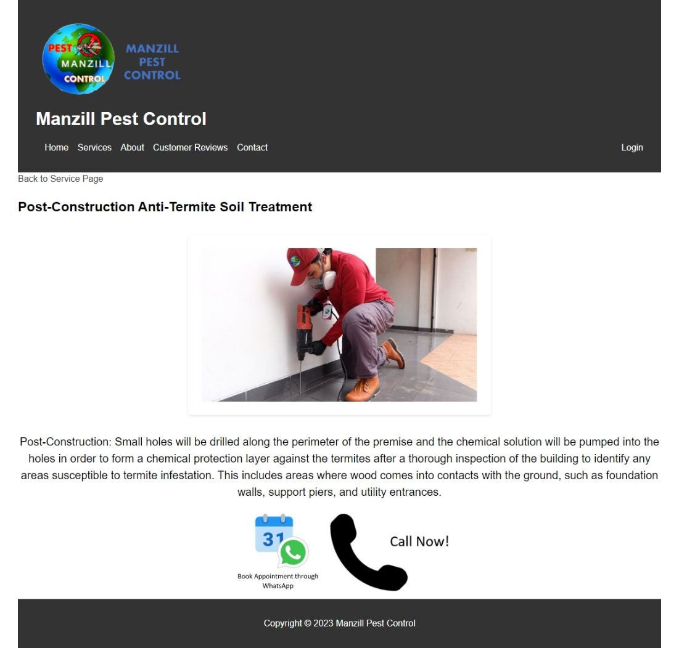

Figure 9 Post-Construction Anti-Termite Soil Treatment

**Code for Post-Construction Anti-Termite Soil Treatment (post-constructment.html)**

|  |
| --- |
| <!DOCTYPE html>  <html>  <head>  <title> Services | Manzill Pest Control</title>  <link href="fav.jpg" rel="icon" />  <link rel="stylesheet" href="ManzillStyleTest.css">  </head>  <body>  <!-- Header -->  <header>  <img src="try.png" alt="Company Logo">  <h1>Manzill Pest Control</h1>  <nav>  <ul>  <li><a href="testindex.html">Home</a></li>  <li><a href="servicepage.html">Services</a></li>  <li><a href="about.html">About</a></li>  <li><a href="custreview.html">Customer Reviews</a></li>  <li><a href="contact.html">Contact</a></li>  </ul>  <a href="login.html">Login</a>  </nav>  </header>  <!-- Service Section -->  <a href="servicepage.html" class="button">Back to Service Page</a>  <section class="servicesec">  <h2> Post-Construction Anti-Termite Soil Treatment </h2>  </section>  <div class="vicephoto">  <img src="post-construction.jpg" alt="Post-Construction Anti-Termite Soil Treatment">  </div>  <div class="vicetext">  <p> Post-Construction: Small holes will be drilled along the perimeter of the premise and the chemical solution will be pumped into the holes in order to form a chemical protection layer against the termites after a thorough inspection of the building to identify any areas susceptible to termite infestation. This includes areas where wood comes into contacts with the ground, such as foundation walls, support piers, and utility entrances. </p>  </div>  <div class="appoint">  <a href="https://wa.me/+60165333235/"><img src="appointment.jpg" alt="Book Appointment through WhatsApp"></a>  <a href="tel:+60165333235"><img src="callnow.jpg" alt="Call Now!"></a>  </div>    <!-- Footer -->  <footer>  <p>Copyright &copy; 2023 Manzill Pest Control</p>  </footer>  </body>  </html> |

**Pre-Construction Anti-Termite Soil Treatment**

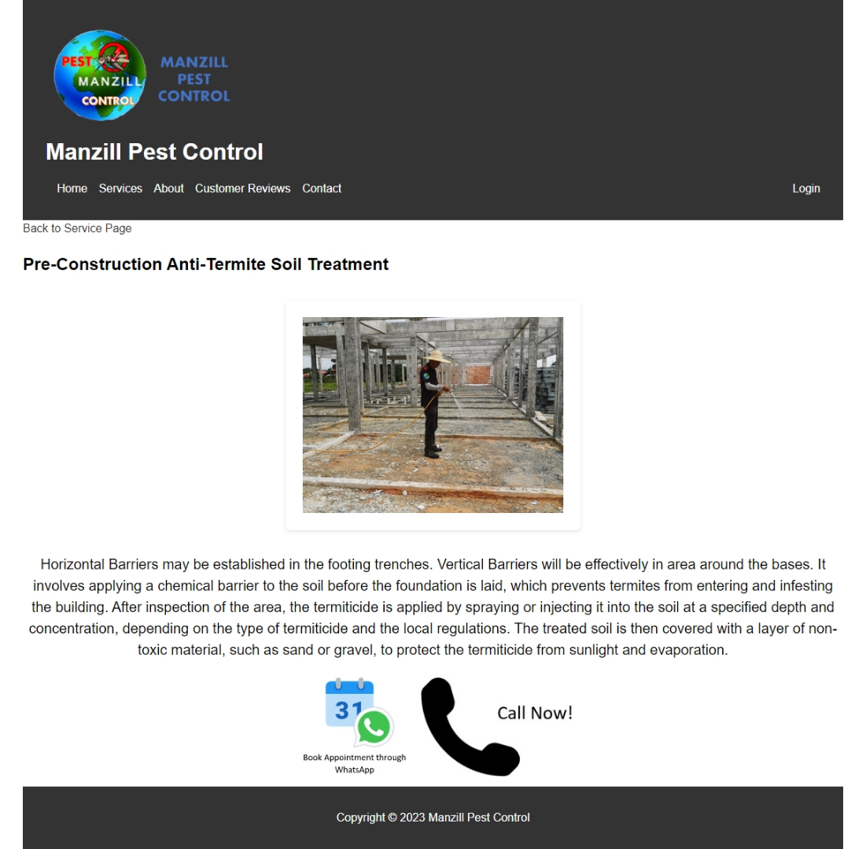

Figure 10 Pre-Construction Anti-Termite Soil Treatment

**Code for Pre-Construction Anti-Termite Soil Treatment (pre-constructment.html)**

|  |
| --- |
| <!DOCTYPE html>  <html>  <head>  <title> Services | Manzill Pest Control</title>  <link href="fav.jpg" rel="icon" />  <link rel="stylesheet" href="ManzillStyleTest.css">  </head>  <body>  <!-- Header -->  <header>  <img src="try.png" alt="Company Logo">  <h1>Manzill Pest Control</h1>  <nav>  <ul>  <li><a href="testindex.html">Home</a></li>  <li><a href="servicepage.html">Services</a></li>  <li><a href="about.html">About</a></li>  <li><a href="custreview.html">Customer Reviews</a></li>  <li><a href="contact.html">Contact</a></li>  </ul>  <a href="login.html">Login</a>  </nav>  </header>  <!-- Service Section -->  <a href="servicepage.html" class="button">Back to Service Page</a>  <section class="servicesec">  <h2> Pre-Construction Anti-Termite Soil Treatment </h2>  </section>  <div class="vicephoto">  <img src="pre-construction.jpg" alt="Pre-Construction Anti-Termite Soil Treatment">  </div>  <div class="vicetext">  <p> Horizontal Barriers may be established in the footing trenches. Vertical Barriers will be effectively in area around the bases. It involves applying a chemical barrier to the soil before the foundation is laid, which prevents termites from entering and infesting the building. After inspection of the area, the termiticide is applied by spraying or injecting it into the soil at a specified depth and concentration, depending on the type of termiticide and the local regulations. The treated soil is then covered with a layer of non-toxic material, such as sand or gravel, to protect the termiticide from sunlight and evaporation. </p>  </div>  <div class="appoint">  <a href="https://wa.me/+60165333235/"><img src="appointment.jpg" alt="Book Appointment through WhatsApp"></a>  <a href="tel:+60165333235"><img src="callnow.jpg" alt="Call Now!"></a>  </div>    <!-- Footer -->  <footer>  <p>Copyright &copy; 2023 Manzill Pest Control</p>  </footer>  </body>  </html> |

## Baiting

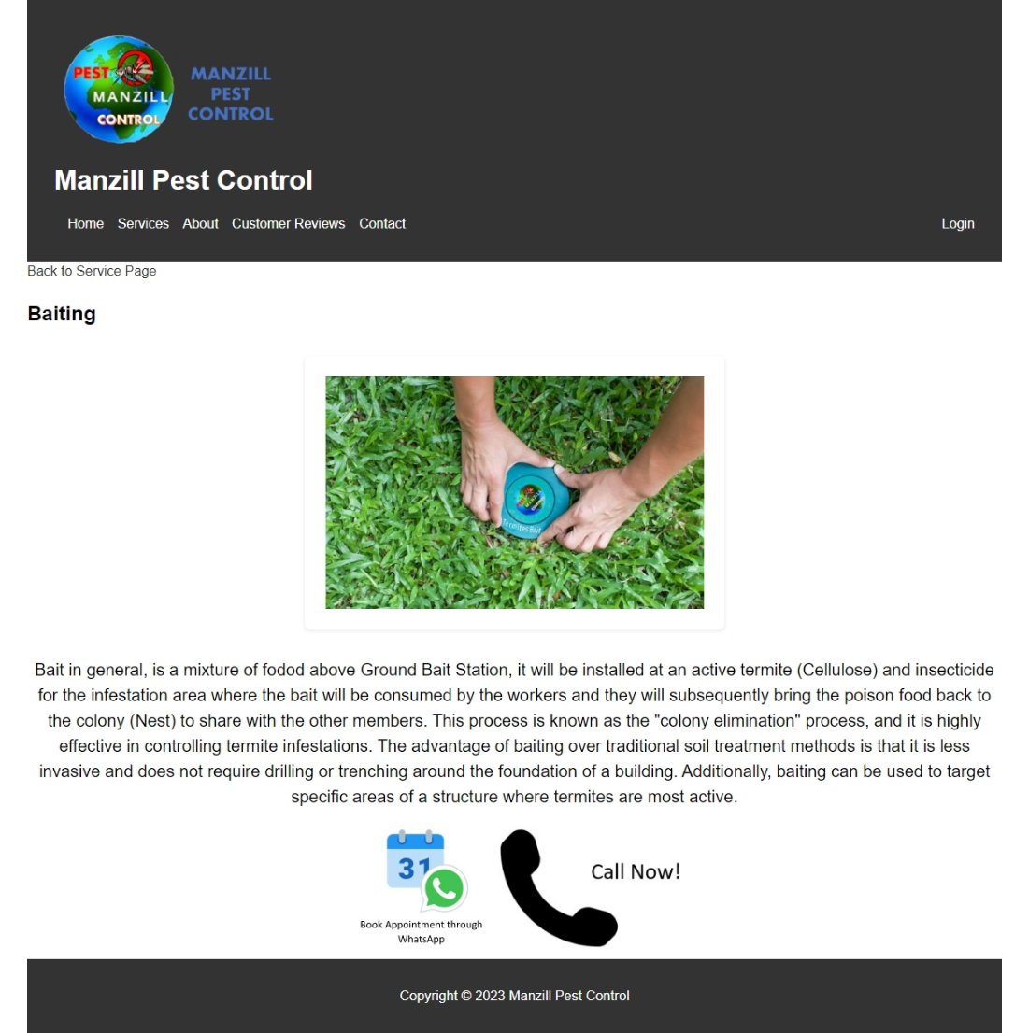

Figure 11 Baiting

**Code for Baiting (baiting.html)**

|  |
| --- |
| <!DOCTYPE html>  <html>  <head>  <title> Services | Manzill Pest Control</title>  <link href="fav.jpg" rel="icon" />  <link rel="stylesheet" href="ManzillStyleTest.css">  </head>  <body>  <!-- Header -->  <header>  <img src="try.png" alt="Company Logo">  <h1>Manzill Pest Control</h1>  <nav>  <ul>  <li><a href="testindex.html">Home</a></li>  <li><a href="servicepage.html">Services</a></li>  <li><a href="about.html">About</a></li>  <li><a href="custreview.html">Customer Reviews</a></li>  <li><a href="contact.html">Contact</a></li>  </ul>  <a href="login.html">Login</a>  </nav>  </header>  <!-- Service Section -->  <a href="servicepage.html" class="button">Back to Service Page</a>  <section class="servicesec">  <h2> Baiting </h2>  </section>  <div class="vicephoto">  <img src="baiting.jpg" alt="Baiting">  </div>  <div class="vicetext">  <p> Bait in general, is a mixture of fodod above Ground Bait Station, it will be installed at an active termite (Cellulose) and insecticide for the infestation area where the bait will be consumed by the workers and they will subsequently bring the poison food back to the colony (Nest) to share with the other members. This process is known as the "colony elimination" process, and it is highly effective in controlling termite infestations.  The advantage of baiting over traditional soil treatment methods is that it is less invasive and does not require drilling or trenching around the foundation of a building. Additionally, baiting can be used to target specific areas of a structure where termites are most active.</p>  </div>  <div class="appoint">  <a href="https://wa.me/+60165333235/"><img src="appointment.jpg" alt="Book Appointment through WhatsApp"></a>  <a href="tel:+60165333235"><img src="callnow.jpg" alt="Call Now!"></a>  </div>    <!-- Footer -->  <footer>  <p>Copyright &copy; 2023 Manzill Pest Control</p>  </footer>  </body>  </html> |

# Graphical user interface, website Description automatically generatedThermal Fogging

Figure 11 Thermal Fogging

**Code for Thermal Fogging (thermalfogging.html)**

|  |
| --- |
| <!DOCTYPE html>  <html>  <head>  <title> Services | Manzill Pest Control</title>  <link href="fav.jpg" rel="icon" />  <link rel="stylesheet" href="ManzillStyleTest.css">  </head>  <body>  <!-- Header -->  <header>  <img src="try.png" alt="Company Logo">  <h1>Manzill Pest Control</h1>  <nav>  <ul>  <li><a href="testindex.html">Home</a></li>  <li><a href="servicepage.html">Services</a></li>  <li><a href="about.html">About</a></li>  <li><a href="custreview.html">Customer Reviews</a></li>  <li><a href="contact.html">Contact</a></li>  </ul>  <a href="login.html">Login</a>  </nav>  </header>  <!-- Service Section -->  <a href="servicepage.html" class="button">Back to Service Page</a>  <section class="servicesec">  <h2> Thermal Fogging </h2>  </section>  <div class="vicephoto">  <img src="thermal fogging.jpg" alt="Thermal Fogging">  </div>  <div class="vicetext">  <p> This type of fog produces fine chemical droplets, which will allow the droplets to be suspended in mid air to kill flying mosquitoes, flies and other insects. It is effective in control mosquitoes at large outdoor areas, such as parks, farms, and golf courses, where conventional sprays may not be effective. It is also used in indoor areas like warehouses, factories, and commercial buildings, where there is a need for fast and efficient control of flying insects.</p>  </div>  <div class="appoint">  <a href="https://wa.me/+60165333235/"><img src="appointment.jpg" alt="Book Appointment through WhatsApp"></a>  <a href="tel:+60165333235"><img src="callnow.jpg" alt="Call Now!"></a>  </div>    <!-- Footer -->  <footer>  <p>Copyright &copy; 2023 Manzill Pest Control</p>  </footer>  </body>  </html> |

# Disinfecting Services/ COVID-19

Figure 11 Disinfecting Services/ COVID-19

**Code for Disinfecting Services/ COVID-19 (disinfection.html)**

|  |
| --- |
| <!DOCTYPE html>  <html>  <head>  <title> Services | Manzill Pest Control</title>  <link href="fav.jpg" rel="icon" />  <link rel="stylesheet" href="ManzillStyleTest.css">  </head>  <body>  <!-- Header -->  <header>  <img src="try.png" alt="Company Logo">  <h1>Manzill Pest Control</h1>  <nav>  <ul>  <li><a href="testindex.html">Home</a></li>  <li><a href="servicepage.html">Services</a></li>  <li><a href="about.html">About</a></li>  <li><a href="custreview.html">Customer Reviews</a></li>  <li><a href="contact.html">Contact</a></li>  </ul>  <a href="login.html">Login</a>  </nav>  </header>  <!-- Service Section -->  <a href="servicepage.html" class="button">Back to Service Page</a>  <section class="servicesec">  <h2> Disinfecting Services/ COVID-19 </h2>  </section>  <div class="vicephoto">  <img src="disinfection.jpg" alt="Disinfecting Services">  </div>  <div class="vicetext">  <p> To Prevent The Spread Of Coronavirus (COVID-19) Infection. Disinfecting services is the process of cleaning and disinfecting surfaces to reduce or eliminate the spread of infectious microorganisms, such as bacteria, viruses, and fungi. Disinfecting services have become essential in controlling the spread of the Coronavirus (COVID-19) as well.</p>  </div>  <div class="appoint">  <a href="https://wa.me/+60165333235/"><img src="appointment.jpg" alt="Book Appointment through WhatsApp"></a>  <a href="tel:+60165333235"><img src="callnow.jpg" alt="Call Now!"></a>  </div>    <!-- Footer -->  <footer>  <p>Copyright &copy; 2023 Manzill Pest Control</p>  </footer>  </body>  </html> |

# Graphical user interface, website Description automatically generatedCommon Flies

Figure 11 Common Flies

**Code for Common Flies (common flies.html)**

|  |
| --- |
| <!DOCTYPE html>  <html>  <head>  <title> Services | Manzill Pest Control</title>  <link href="fav.jpg" rel="icon" />  <link rel="stylesheet" href="ManzillStyleTest.css">  </head>  <body>  <!-- Header -->  <header>  <img src="try.png" alt="Company Logo">  <h1>Manzill Pest Control</h1>  <nav>  <ul>  <li><a href="testindex.html">Home</a></li>  <li><a href="servicepage.html">Services</a></li>  <li><a href="about.html">About</a></li>  <li><a href="custreview.html">Customer Reviews</a></li>  <li><a href="contact.html">Contact</a></li>  </ul>  <a href="login.html">Login</a>  </nav>  </header>  <!-- Service Section -->  <a href="servicepage.html" class="button">Back to Service Page</a>  <section class="servicesec">  <h2> Disinfecting Services/ COVID-19 </h2>  </section>  <div class="vicephoto">  <img src="disinfection.jpg" alt="Disinfecting Services">  </div>  <div class="vicetext">  <p> To Prevent The Spread Of Coronavirus (COVID-19) Infection. Disinfecting services is the process of cleaning and disinfecting surfaces to reduce or eliminate the spread of infectious microorganisms, such as bacteria, viruses, and fungi. Disinfecting services have become essential in controlling the spread of the Coronavirus (COVID-19) as well.</p>  </div>  <div class="appoint">  <a href="https://wa.me/+60165333235/"><img src="appointment.jpg" alt="Book Appointment through WhatsApp"></a>  <a href="tel:+60165333235"><img src="callnow.jpg" alt="Call Now!"></a>  </div>    <!-- Footer -->  <footer>  <p>Copyright &copy; 2023 Manzill Pest Control</p>  </footer>  </body>  </html> |

# Graphical user interface Description automatically generatedRodent Bait

Figure 11 Rodent Bait

**Code for Rodent Bait (rodent.html)**

|  |
| --- |
| <!DOCTYPE html>  <html>  <head>  <title> Services | Manzill Pest Control</title>  <link href="fav.jpg" rel="icon" />  <link rel="stylesheet" href="ManzillStyleTest.css">  </head>  <body>  <!-- Header -->  <header>  <img src="try.png" alt="Company Logo">  <h1>Manzill Pest Control</h1>  <nav>  <ul>  <li><a href="testindex.html">Home</a></li>  <li><a href="servicepage.html">Services</a></li>  <li><a href="about.html">About</a></li>  <li><a href="custreview.html">Customer Reviews</a></li>  <li><a href="contact.html">Contact</a></li>  </ul>  <a href="login.html">Login</a>  </nav>  </header>  <!-- Service Section -->  <a href="servicepage.html" class="button">Back to Service Page</a>  <section class="servicesec">  <h2>Rodent Bait</h2>  </section>  <div class="vicephoto">  <img src="rodent.jpg" alt="Rodent Bait">  </div>  <div class="vicetext">  <p> External perimeter (EPBS) and Tamper-resistant (TRBS) bait stations will be installed along the perimeter of the premise in order to create a defense line against the rats. In addition, they also serve as a monitoring tool as they can provide information such as bait consumption and infestation level. EPBS and TRBS bait stations are particularly effective in controlling rats because they are placed in areas where rats are likely to travel, such as along walls and fences. This helps to create a barrier that prevents rats from entering the premise, which reduces the risk of damage and disease transmission.</p>  </div>  <div class="appoint">  <a href="https://wa.me/+60165333235/"><img src="appointment.jpg" alt="Book Appointment through WhatsApp"></a>  <a href="tel:+60165333235"><img src="callnow.jpg" alt="Call Now!"></a>  </div>    <!-- Footer -->  <footer>  <p>Copyright &copy; 2023 Manzill Pest Control</p>  </footer>  </body>  </html> |

**Manzill Style (ManzillStyleTest.css)**

|  |
| --- |
| body {  font-family: 'Helvetica Neue', sans-serif;  line-height: 1.5;  margin: 0;  padding: 0;  }  a {  color: #333;  text-decoration: none;  }  a:hover {  text-decoration: underline;  }  h1, h2 {  font-weight: 700;  margin-bottom: 1rem;  }  ul {  list-style: none;  margin: 0;  padding: 0;  }  /* Header */  header {  background-color: #333;  color: #fff;  padding: 2rem;  }  header h1 {  margin: 0;  }  header img {  margin: 0;  width: auto-size;  height: 150px;  }  header nav {  display: flex;  justify-content: space-between;  align-items: center;  margin-top: 1rem;  }  header nav ul {  display: flex;  }  header nav li {  margin-left: 1rem;  }  header nav a {  color: #fff;  }  /* Hero Section */  .hero {  background-image: url("image1.png");  background-position: center;  background-size: cover;  height: 400px;  display: flex;  justify-content: center;  align-items: center;  text-align: center;  color: #fff;  }  .hero h1 {  font-size: 4rem;  margin: 0;  }  /* Pictures Section */  .pictures {  justify-content: center;  align-items: center;  text-align: center;  }  .pictures img{  float: left;  max-width: 50%;  height: 428px;  width: auto-size  display: flex;  }  /*About Section*/  .about, .service {  background-color: #fff;  border-radius: 5px;  box-shadow: 0 2px 4px rgba(0,0,0,.1);  margin: 1rem;  padding: 1.5rem;  display: flex;  justify-content: space-between;  flex-wrap: wrap;  justify-content: center;  text-align: center;  align-items: center;  }  /* Services Section */  .services {  background-color: #f7f7f7;  padding: 2rem;  }  .services h2 {  margin-top: 0;  }  .services ul {  display: flex;  justify-content: space-between;  flex-wrap: wrap;  }  .services li {  flex: 1 1 300px;  background-color: #fff;  border-radius: 5px;  box-shadow: 0 2px 4px rgba(0,0,0,.1);  margin: 1rem;  padding: 1.5rem;  text-align: center;  }  .services li img {  width: auto-size;  height: 225px;  }  .services li h3 {  margin: 1;  }  .services li p {  color: #666;  }  .vicephoto,.appoint {  justify-content: center;  text-align: center;  align-items: center;  }  .vicephoto img{  flex: 1 1 300px;  background-color: #fff;  border-radius: 5px;  box-shadow: 0 2px 4px rgba(0,0,0,.1);  margin: 1rem;  padding: 1.5rem;  justify-content: center;  text-align: center;  align-items: center;  width: auto-size;  height: 275px;  }  .vicetext p{  margin-top: 10px;  text-align: center;  font-size: 20px;  }  .appoint a img {  justify-content: center;  text-align: center;  align-items: center;  width: auto-size;  height: 150px;  }  /* Partner Section In About Page*/  .partner-section {  padding: 50px 0;  text-align: center;  }  .partner-list {  display: flex;  flex-wrap: wrap;  justify-content: center;  margin-top: 30px;  }  .partner {  width: 300px;  margin: 20px;  padding: 20px;  border: 1px solid #ccc;  border-radius: 5px;  }  .partner a {  width: auto-size;  height: 100px;  border-radius: 5px;  margin-up: 10px;  }  .partner img {  width: auto-size;  height: 100px;  border-radius: 5px;  margin-up: 10px;  }  .partner h3 {  font-size: 24px;  margin-bottom: 10px;  }  .partner p {  font-size: 16px;  line-height: 1.5;  }  /*Contact Section*/  #contact {  background-color: #f2f2f2;  padding: 50px;  text-align: center;  }  .contactus {  max-width: 500px;  margin: auto;  }  .contactus h1 {  margin-top: 0;  font-size: 2.5rem;  color: #333;  }  .contactus p {  font-size: 1.2rem;  color: #555;  }  label {  display: block;  margin-bottom: 10px;  font-size: 1.2rem;  color: #333;  }  input[type="text"],  input[type="email"],  input[type="tel"],  textarea {  width: 100%;  padding: 10px;  margin-bottom: 20px;  border: none;  border-radius: 4px;  box-shadow: 0 0 8px rgba(0, 0, 0, 0.1);  font-size: 1.2rem;  color: #333;  }  textarea {  height: 120px;  }  button[type="reset"] {  background-color: #008CBA;  color: #fff;  border: none;  border-radius: 4px;  padding: 10px 20px;  font-size: 1.2rem;  cursor: pointer;  transition: all 0.3s ease;  }  button[type="submit"]:hover {  background-color: #006080;  }  /* Our Location at Contact Page */  .maps, .map {  justify-content: center;  text-align: center;  align-items: center;  }  /* Customer Review Page */  rev h1 {  text-align: center;  margin-top: 50px;  }  .review {  border: 1px solid #ccc;  padding: 20px;  margin-bottom: 20px;  justify-content: center;  text-align: center;  align-items: center;  }  .review h3 {  margin-top: 0;  }  .review p {  margin: 10px 0;  }  .review .rating {  margin-top: 10px;  display: flex;  justify-content: center;  }  .review .rating span {  font-size: 24px;  color: #f5a623;  margin: 0 5px;  }  .review .author {  text-align: right;  font-style: italic;  color: #666;  }  /* Login Page */  .loginpg {  margin: 50px auto;  padding: 20px;  max-width: 400px;  background-color: #fff;  border-radius: 10px;  box-shadow: 0 0 10px rgba(0, 0, 0, 0.2);  }  .loginpg h1 {  text-align: center;  margin-bottom: 20px;  }  .loginpg label {  display: block;  margin-bottom: 10px;  font-weight: bold;  }  input[type="text"],  input[type="password"] {  width: 100%;  padding: 10px;  margin-bottom: 20px;  border: 1px solid #ccc;  border-radius: 5px;  box-sizing: border-box;  }  button {  display: block;  width: 100%;  padding: 10px;  margin-top: 20px;  background-color: #4caf50;  color: #fff;  border: none;  border-radius: 5px;  /*cursor: pointer;*/  font-size: 16px;  }  button:hover {  background-color: #3e8e41;  }  .forgot-password {  text-align: center;  margin-top: 20px;  }  .forgot-password a {  color: #777;  text-decoration: none;  font-size: 14px;  }  .forgot-password a:hover {  color: #333;  }  .signup {  text-align: center;  margin-top: 20px;  }  .signup a {  color: #777;  text-decoration: none;  font-size: 14px;  }  .signup a:hover {  color: #333;  }  /* Footer */  footer {  background-color: #333;  color: #fff;  padding: 2rem;  text-align: center;  }  footer p {  margin: 0;  }  footer a {  color: #fff;  }  @media (min-width: 768px) {  body {  padding: 0 2rem;  }  header nav ul {  margin-right: 2rem;  }  .hero h1 {  font-size: 6rem;  }  .services ul {  display: flex;  justify-content: space-between;  }  .services li {  flex: 1 1 calc(33.33% - 2rem);  }  } |

# Conclusion

This Manzill Pest Control website provides a seamless and hassle-free experience for customers looking for reliable and effective pest control solutions. Pests such as termites, ants, and rodents can cause extensive damage to homes and commercial buildings, which can be expensive to repair. Regular pest control services by booking appointments or calling through this website can help detect and prevent such damage, which can save property owners a significant amount of money in the long run. Pests can contaminate food and water sources, causing health hazards and sanitation issues, mostly food and beverages shops. With the help of the website, they can seek for the services that can help maintain cleanliness and hygiene in residential and commercial spaces by eliminating pests and preventing their re-infestation.

# Reference

1. Developer.mozilla.org. 2023. *CSS first steps - Learn web development | MDN*. <https://developer.mozilla.org/en-US/docs/Learn/CSS/First_steps>
2. Html.com. 2023. *Home*. <https://html.com/>
3. JavaScript Tutorial. 2023. *JavaScript Tutorial*. <https://www.javascripttutorial.net/>
4. Tutorialspoint.com. 2023. *CSS Tutorial*. <https://www.tutorialspoint.com/css/index.htm>
5. Tutorialspoint.com. 2023. *HTML Tutorial*.<https://www.tutorialspoint.com/html/index.htm>
6. ‌Tutorialspoint.com. 2023. *Javascript Tutorial*. <https://www.tutorialspoint.com/javascript/index.htm>
7. W3schools.com. 2023. *CSS Tutorial*. <https://www.w3schools.com/css/default.asp>
8. W3schools.com. 2023. *HTML Tutorial*. <https://www.w3schools.com/html/default.asp>
9. W3schools.com. 2023. *JavaScript Tutorial*. <https://www.w3schools.com/js/default.asp>
10. www.javatpoint.com. 2023. *Learn JavaScript Tutorial - javatpoint*. <https://www.javatpoint.com/javascript-tutorial>